Dine and Make a Difference!
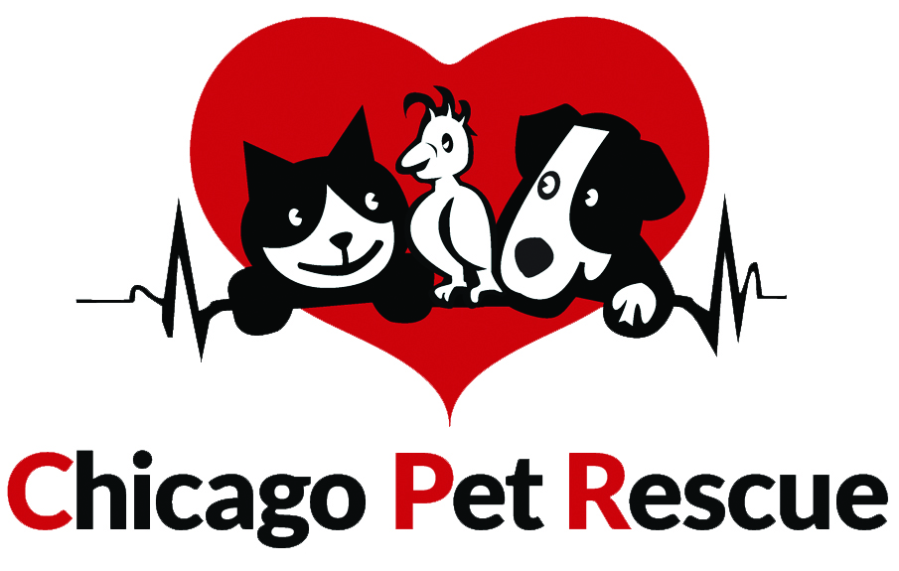

Chicago Pet Rescue invites you to join us in our Pasta D’Arte Fundraiser. This is a great way to help raise money for homeless animals! It won’t cost you anything extra and you get to enjoy a delicious meal.

The way it works is that you, your friends and family dine in or carry out, and Pasta D’Arte will donate 15% of your pre-taxed total to CPR!

February 16 - 22, 2015
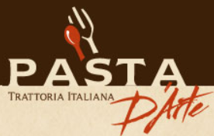
6311 N. Milwaukee Ave. Chicago, IL
(773) 763-1181
**You MUST present THIS flyer.**
www.chicagopetrescue.org

-------------------------------------------------------------------------------------------------------------------

Dine and Make a Difference!

Chicago Pet Rescue invites you to join us in our Pasta D’Arte Fundraiser. This is a great way to help raise money for homeless animals! It won’t cost you anything extra and you get to enjoy a delicious meal.

The way it works is that you, your friends and family dine in or carry out, and Pasta D’Arte will donate 15% of your pre-taxed total to CPR!

February 16 - 22, 2015
6311 N. Milwaukee Ave. Chicago, IL
(773) 763-1181
**You MUST present THIS flyer.**
www.chicagopetrescue.org

